

Offer Definition
For Avaya Distributors in the MEA, Turkey, and Russia / CIS Region
Win with IP Office Promotion!

Last updated: 9 November 2015
Promotion start date: 16th February 2014
Promotion end date: Extended until 27th September 2016
Geographic availability: Middle East, Africa, Turkey, and Russia/CIS

Contents
Change Log 3
Introduction 4
Promotion Description 4
Small Solution 5
SUMMER OFFER – Extended until 31 December 2015 6
Mid Market UC Solution 8
Win with IP Office Lite - Expansions 10
Avaya Partner Value Proposition 11
Distributors’ Process / Rules 11
Promotion Terms and Conditions 11
General Promotion and Package Terms and Conditions 11
Resources 11
Contacts 11

Change Log

12 August: Updated offer definition with Win with IP Office Summer offer and construct details in appendix D.
31 August: Added Win with IP Office Lite package option
1 October:
- Extension notification until 27th September 2016
- Removal of the Summer Offer
- Explanation of the ASIPP offer being able to trigger the Win with IP Office promotion
- Adjustment of bulk orders requiring to be >$50K List price
9 November:
- Re-instate Summer Offer until 31st December 2015
- Increased Networking discounts to entice greater attach, covering all products in the product category listed with some exceptions & exclusions. Therefore the Appendix with all the Networking product codes has been removed.

Introduction

Achieve success bringing rich, powerful unified communications capabilities to your customers with the Win with IP Office promotion. Avaya IP Office is the perfect solution for your customer up to 2,500 users, one that will easily and cost-effectively scale up as their business grows. With the Win with IP Office promotion, you can offer customer’s unified communications through Avaya’s flagship collaboration platform at a promotional discount that will help you win the deal.

Promotion is available to Avaya IP Office resellers in the Middle East, Africa, Turkey, India and Russia/CIS region (excluding Israel) until 27th September 2016. Requirements for eligibility and discount rates are shown below. Please review the offer document for a complete list of discountable material codes.

Promotion Description
Avaya is pleased to announce the Win with IP Office promotion. The promotion is being extended till 27th September 2016. Resellers must place the order by 27th September 2016; Distributors must ship and invoice the entire solution by 30th September 2015.

The Win with IP Office Promotion is modified to have two distinct options targeting different use cases & scenarios.
- IP Office for Small Customers – the sub 100 user segment*
- IP Office for the Mid Market – the >100 user segment*
- Win with IP Office Lite – for after-market expansions
- Summer Offer - Extended until 31st December 2015 (see details in the Small Solution section)

*NOTE: For both these segments starting 1st October 2015, the Win with IP Office promotion can be position for new acquisition sales, as well as installed base migrations where now the ASIPP Licenses will trigger the promotion (ASIPP = Avaya SW Investment Protection Policy).

Detail on all these are outlined below.

Small Solution
Promotion detail
In order to facilitate ease of selling into the sub 100 user segment this part of the promotion is exclusively using bundles of fixed configurations at different user sizes at a fixed price – which includes the main IP Office hardware and software requirements. In summary the following construct bundles are available:

Number of users | Essential Edition |  |  |  |  |  | Preferred Edition
Number of users | Analog Phones |  | Digital Phones |  | IP Phones |  | Analog Phones |  | Digital Phones |  | IP Phones
Number of users | Analog Trunks | BRI Trunks | Analog Trunks | BRI Trunks | Analog Trunks | BRI Trunks | Analog Trunks | BRI Trunks | Analog Trunks | BRI Trunks | Analog Trunks | BRI Trunks
8 | YES | NO | YES | YES | YES | YES | NO | NO | NO | NO | NO | NO
24 | YES | NO | YES | YES | YES | YES | NO | NO | NO | NO | YES | NO
48 | YES | NO | YES | YES | YES | YES | NO | NO | NO | NO | YES | NO
78 | YES | NO | YES | NO | YES | YES (PRI) | NO | NO | NO | NO | NO | YES (PRI)

Detail on what is included in each of the bundles can be found in Appendix A. There is the ability to design flexible configurations, which have slightly different discounts.

The discounts are as follows:

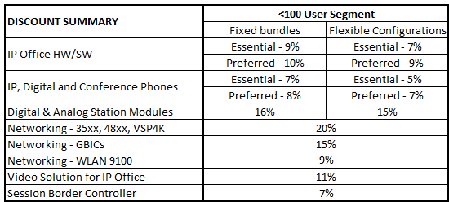
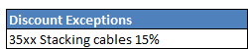

SUMMER OFFER – Extended until 31 December 2015
To strengthen the bread of the Win with IP Office promotion additional Multimedia Bundles will be added to the promotion, including ERS 3500 switches, H175 Video Phone, XT5000 for IP Office and E159/H169 Media Stations. The bundle detail can be found in Appendix D, and a separate validation sheet has been created for multiple bundle ordering. The discounts are as follows:

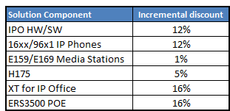

Eligibility Requirements & Conditions
- IP Office R9.1 Licenses
- Min 8 extensions (ASIPP or non-ASIPP)
- Fixed configurations have to be ordered as offered, no changes can be made
- Digital and IP bundles require the corresponding number of Digital, IP and Conference phones to be purchased with it before the bundle discounts can be applied
  - For example the 24 IP Essential bundle requires exactly 24 phones to be purchased with a mix of IP phones and conference phones. A maximum of 2 conference phones can be purchased per bundle.
    - The 8 Digital Basic or Essential Bundles only require 6 digital phones to be purchased
    - The 24 Digital Basic or Essential Bundles only require 22 digital phones to be purchased
- Anything that the customer requires outside of the bundles, needs to be purchased separately and at standard pricing or leverage the Flexible configuration option
- On the flexible configuration options:
  - Minimum 80% phone attach requirement vs licenses/ports
    - The min phone attach is required for all Digital Ports and IP licenses but not for ASIPP, 3rd Party or Power User licenses;
      - To support small IP configurations the 6 digital ports on the BRI and Analog trunk Combo card also don’t require the minimum phone attach.
    - The phones counted towards this 80% is any IP, Digital, DECT or Conference Phone.
  - The Phone attach can be maximum of 105% of the total IP licenses + digital ports
    - The max phone attach counts all Digital Ports and IP licenses including Power Users, ASIPP and 3rd Party
    - The phones counted towards this 105% is any IP, Digital, DECT or Conference Phone.
      - If these quantities are exceeded the additional quantities will be moved to a separate purchase order and will not receive the promotional discounts.
      - Avaya and the distributor reserve the right to question other product quantities if they appear to be in excess.

Operationalisation
The Win with IP Office Promotion is available in the Marketing Promotions Module, and for single customer orders can be quoted and priced up instantly without the need to raise a special bid. Ensure your quote is in Ready to Order status, Check for Promotions, and Apply the Promotion.

Key tips to ensure that your quote triggers a fixed bundle promotion are
- Ensure you use the validation sheet to create the BOQ
- Ensure the license codes in the quote are ADI licenses and not PLDS

As of March 13, 2015 there are new promotion codes in the Marketing Promotion Module:
Sales Scenario | New Promo Codes
IP Office Fixed Bundles - Essential | GGMWIPO-FXDESS
IP Office Fixed Bundles - Preferred | GGMWIPO-FXDPRF
IP Office Flexible Bundles - Essential | GGMWIPO-FLXESSL
IP Office Flexible Bundles - Preferred | GGMWIPO-FLXPREF
Summer Offer | GGMWIPO-SO

Exclusions: Promotional discounts are not applicable on the following items:
- DECT and WIFI Phones solutions
- ASIPP Software material codes
- 3526T non-PWR switches

For bulk orders of the fixed bundles for orders greater than $50K LIST price only, the process is to raise a special bid request using the following process:
NOTE: single bundle orders or small bulk orders less than $50K are not permitted to use special bid process anymore and need to use the Marketing Promotions Module, any request for single bundle orders or small bulk orders less than $50K through special bid will be rejected.
- Fill the “Bundle Validation Sheet” for the entire order of a partner. Multiple bundles can be combined in a single quote/order.
- Bundle validation sheet will produce a consolidated BOQ for the order.
- Create a new merchandize quote in Avaya’s One Source tool for with the BOQ
  - The exact quantities of the items as per Appendix A.
  - A mix phones & conference phones, with a total quantity as required per the promotion rules.
- Ensure that the quote is at ready-to-order status.
- Request your Avaya associate/Distributor to raise an SBA for you. And the subsequent steps will be the same as usual SBAs. However, there will be flexibility of not reporting end-user name at the time partner buys the bundles stock. They will be allowed to report the enduser information once the bundles are sold to actual end-customers. For details on this process, please refer to attached addendum “Reseller Stocking Trial”.

Mid Market UC Solution
Promotion detail
The element of the Win with IP Office promotion targeting the 100 users and higher customer segment is quite straightforward, and the incremental discounts are as follows

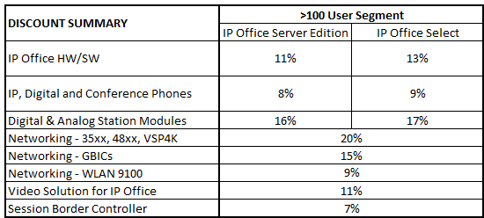

Eligibility Requirements & Conditions
The eligibility requirements for this promotion are as follows:
- At least 1 x IP Office Server Edition or IP Office Select R9.1 is required
- At least 5% of the total number of users must have Power User licenses.
- Minimum of 100 users – R9.x IP (ASIPP or non-ASIPP), Digital and/or Analog
- Phone attach requirements
  - Minimum 80% phone attach requirement vs licenses/ports
    - The min phone attach is required for all Digital Ports and IP licenses but not for ASIPP, 3rd Party or Power User licenses;
    - The phones counted towards this 80% is any IP, Digital, DECT or Conference Phone.
  - The Phone attach can be maximum of 105% of the total IP licenses + digital ports
    - The max phone attach counts all Digital Ports and IP licenses including Power Users, ASIPP and 3rd Party
    - The phones counted towards this 105% is any IP, Digital, DECT or Conference Phone.
      - If these quantities are exceeded the additional quantities will be moved to a separate purchase order and will not receive the promotional discounts.
      - Avaya and the distributor reserve the right to question other product quantities if they appear to be in excess.

Exclusions: Promotional discounts are not applicable on the following items:
- DECT and WIFI Phones solutions
- ASIPP Software material codes
- 3526T non-PWR switches
Operationalisation

The Win with IP Office Promotion is available in the Marketing Promotions Module, and Server Edition and IP Office Select orders can be quoted and priced up instantly without the need to raise a special bid in the Marketing Promotions Module. Ensure your quote is in Ready to Order status, Check for Promotions, and Apply the Promotion.
As of March 13, 2015 there are new promotion codes in the Marketing Promotion Module:
Sales Scenario | New Promo Codes
IP Office Server Edition | GGMWIPO-IPOSE
IP Office Select | GGMWIPO-IPOSL

Win with IP Office Lite - Expansions
Promotion detail
This element of the Win with IP Office promotion & packages has been added to support the following customer use cases:
- Small expansions
- Basic IP Office sales (where Essential Edition is not a requirement)
- Standalone IP Office Contact Center, Avaya Contact Center Select, SBC or other IP Office application upsell opportunities

The incremental discounts are as follows:
Solution/Portfolio | MEA / Turkey | India, CIS, Hong Kong, Taiwan and Macau
IP Office HW/SW | 5% | 5%
IPOCC / ACCS | 5% | 5%
SBC for IP Office | 5% | 5%
IP Phones – 16xx/96x1 | N/A | 5%
Digital Phones – 14xx/94xx/95xx | N/A | 5%
B1xx Conference Phones | N/A | 5%
IP DECT | N/A | 5%
E159/E169 Media Stations | N/A | 5%

Eligibility Requirements & Conditions
The eligibility requirements for this promotion are as follows:
- Minimum deal size: $5,000 List price
- Maximum deal size: $50,000 List price
- These discounts are not available on ASIPP codes

Operationalisation

The Win with IP Office Lite Package is available in the Marketing Promotions Module and can be quoted and priced up instantly without the need to raise a special bid. Ensure your quote is in Ready to Order status, Check for Promotions, and Apply the Promotion.
As of 31 August 2015 there are new promotion codes in the Marketing Promotion Module:
Geography | New Promo Codes
Win with IP Office Lite – MEA, Turkey | WIPO-EXP-MEATK
Win with IP Office Lite – India, CIS, Hong Kong, Taiwan and Macau | WIPO-EXP-CISIHT

Avaya Partner Value Proposition
- High revenue and margin sales
- Competitive offer against Panasonic, Cisco, and other competitive systems
- Migration offer to retain customers who currently have legacy Avaya/Nortel systems
- Reoccurring and profitable product and services up-sell

Distributors’ Process / Rules
For Distributors’ Process/Rules please reference the Global Distributor Handbook. Distributor will refer to the flow chart for additional information in reference to processing the eligible discount.

Promotion Terms and Conditions
Avaya partner must place the order in one PO with the minimum configuration from the email confirmation by 27 September 2015. The distributor must ship and invoice the full solution by 30 September 2015. Non-compliant orders will automatically be rejected by the distributor.

General Promotion and Package Terms and Conditions
Promotional Terms & Conditions (General, Global)
Please see standard terms and conditions available from the Avaya Sales and Partner Portal at https://sales.avaya.com/documents/1399552195998

Resources
Win with IP Office Promotion web page: https://sales.avaya.com/en/general/win-with-avaya-ip-office---emea

Contacts
Questions: In the first instance, please contact your local Distributor or your Avaya Channel Account Manager (CAM)

Promotion Managers:
- Khalid Khan, khank@avaya.com, +97144048118
- Vincent Uppelschoten, vuppelschoten@avaya.com, +44 1483 309 057 (backup)
APPENDIX A – Sub 100 USER BUNDLES DETAIL, QUANTITIES AND DISCOUNTS
Note that various updates have been made in discounts and material codes due to lifecycle changes (eg. The introduction of IP Office R9.1), all fields in the bundles that have changed have been highlighted in orange.

ANALOG BUNDLES
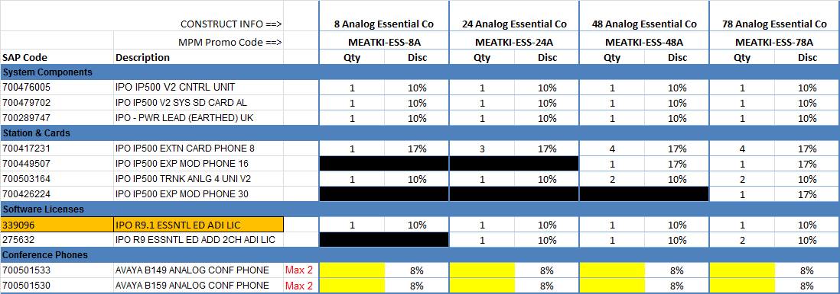
DIGITAL BUNDLES
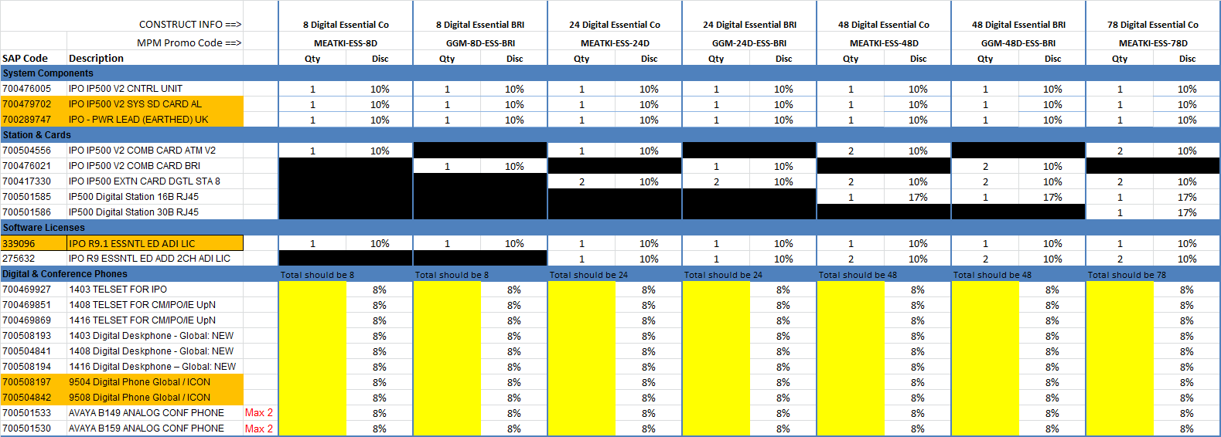
IP BUNDLES – ESSENTIAL
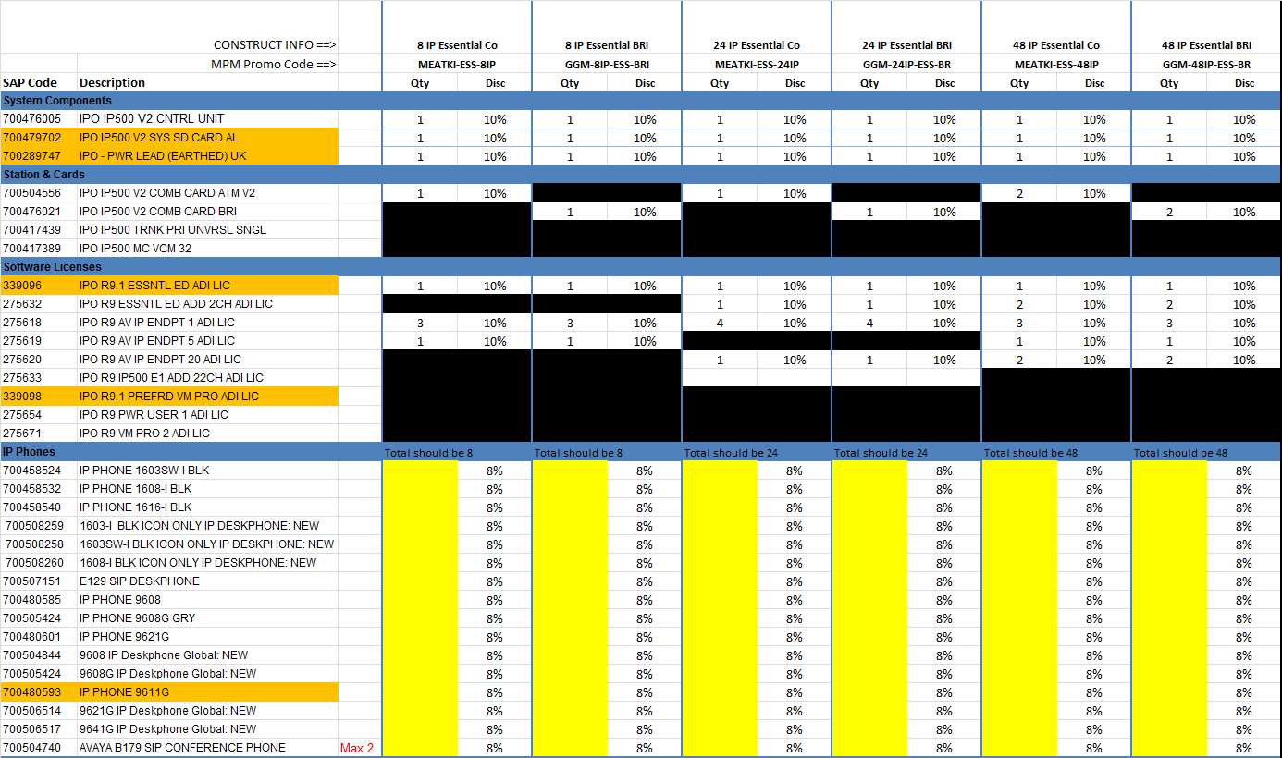

IP BUNDLES – PREFERRED
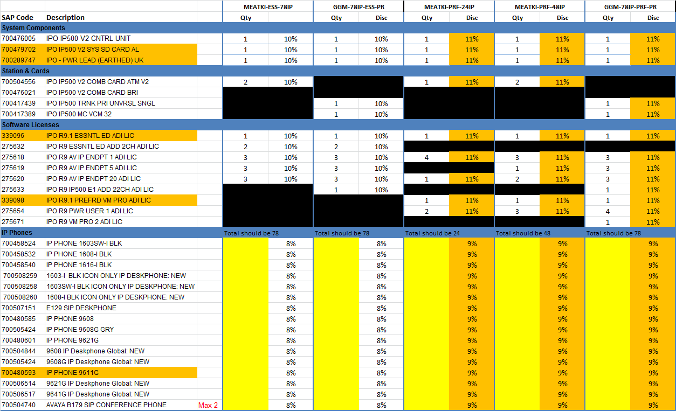

APPENDIX B – PROMOTION MATERIAL CODE EXCLUSION LIST
DECT D100
700503099 | D100 IP DECT KIT WITH BASE STATION AND HANDSET EUROPE | 3P
700503101 | D160 IP DECT HANDSET WITH CHARGER EUROPE | 3P
700503105 | D100 IP DECT REPEATER EUROPE | 3P
700504738 | D100 IP DECT BASE STATION EUROPE | 3P
700503106 | D160 FRMW UPG CBL | 3P
700503108 | D160 PWR SUPP FOR D160 CHRGR GLOBAL | 3P
700503109 | D160 CHRGR W/O PWR SUPP | 3P
700503110 | D160 BATTERY | 3P
700503111 | D160 BELT CLIP | 3P
DECT R4
DECT R4 Phones, chargers and accessories
700466105 | DECT 3720 HANDSET | 3P
700466139 | DECT 3725 HANDSET | 3P
700466253 | DECT HANDSET BASIC CHARGER KIT EUROPEAN | 3P
700466279 | DECT HANDSET ADVANCED CHARGER KIT EUROPEAN | 3P
700466329 | DECT MULTI-BATTERY CHARGER FOR 3725 | 3P
700466683 | DECT 3720 HANDSET BATTERY PACK | 3P
700466691 | DECT 3725 HANDSET BATTERY PACK | 3P
700466568 | DECT HANDSET 3720 BASIC BELT CLIP | 3P
700466337 | DECT HANDSET 3725 SWIVEL BELT CLIP | 3P
700471576 | DECT HANDSET LEATHER CASE 3720 | 3P
700471584 | DECT HANDSET LEATHER CASE 3725 | 3P
DECT R4 ruggedized Phones, chargers and accessories
700479454 | DECT 3740 HANDSET | 3P
700479462 | DECT 3749 HANDSET | 3P
700479470 | DECT 374x HANDSET BASIC CHARGER KIT EUROPEAN | 3P
700479488 | DECT 374x HANDSET ADVANCED CHARGER KIT EUROPEAN | 3P
700479496 | DECT 37xx HANDSET RACKMOUNT CHARGER KIT | 3P
700479504 | DECT MULTI-BATTERY CHARGER FOR 3740 | 3P
700479512 | DECT 374x HEADSET MICROPHONE ON BOOM | 3P
700500879 | DECT 374x HEADSET ADAPTER QD | 3P
700479520 | DECT 374x HEADSET INDUSTRY | 3P
700479538 | DECT 374x HEADSET ADAPTER INDUSTRY AND ATEX | 3P
700500841 | DECT 3740 HANDSET BATTERY PACK | 3P
700500842 | DECT 3749 HANDSET BATTERY PACK | 3P
700500843 | DECT 3749 BATTERY PACK OPENER | 3P
700479546 | DECT HANDSET LEATHER CASE 374x | 3P
700479553 | DECT 374x HANDSET BASIC BELT CLIP | 3P
700479561 | DECT 374x HANDSET SWIVEL BELT CLIP | 3P
DECT R4 Base Stations
700502016 | DECT IP RADIO BASE STATION VERSION 2 WITH INTERNAL ANTENNA | 3P
700502034 | DECT IP RADIO BASE STATION COMPACT VERSION 2 IP OFFICE | 3P
700502015 | DECT IP RADIO BASE STATION VERSION 2 WITH EXTERNAL ANTENNA | 3P
700466444 | DECT RADIO BASE STATION POWER SUPPLY EUROPEAN | 3P
700501200 | DECT RADIO BASE STATION OUTDOOR HOUSING V2 | 3P
700466535 | DECT RADIO BASE STATION DIRECTIONAL DUAL ANTENNA KIT | 3P
700466543 | DECT RADIO BASE STATION DIRECTIONAL SINGLE ANTENNA KIT | 3P
700466550 | DECT RADIO BASE STATION OMNIDIRECTIONAL SINGLE ANTENNA KIT | 3P
700501201 | DECT RADIO BASE STATION POLE MOUNTING KIT V2 | 3P
DECT R4 other items
700471568 | DECT SARI CERTIFICATE | 3P
700501480 | DECT AVAYA INBUILDING WIRELESS SERVER R2 BASIC | 3P
700501481 | DECT AVAYA INBUILDING WIRELESS SERVER R2 BASIC+ | 3P
700501482 | DECT AVAYA INBUILDING WIRELESS SERVER R2 STANDARD | 3P
700501483 | DECT AVAYA INBUILDING WIRELESS SRVR R2 OPEN APPLICATION PROTOCOL | 3P
700501484 | DECT AVAYA INBUILDING WIRELESS SERVER R2 ENTERPRISE MANAGEMENT | 3P
700501993 | DECT IP DECT GATEWAY 48VDC/110-230VAC TO SUPPORT 16 ISDN BS | 3P
700501994 | DECT ISDN BASE STATION STANDARD 1880-1900 MHZ | 3P
700501996 | DECT ISDN BASE STATION STANDARD EXTERNAL ANTENNA 1880-1900 MHZ | 3P
Wifi Phones & chargers
3641 and 3645 (802.11a/b/g)
700430408 | AVAYA WIRELESS 3641 WIRELESS PHONE | 3P
700430416 | AVAYA WIRELESS 3645 WIRELESS PHONE | 3P
3641/ 3645 chargers, batteries, power supplies & accessories
700430424 | AVAYA WIRELESS SINGLE CHARGING STAND FOR 3641 AND 3645 | 4P
700430432 | AVAYA WIRELESS DUAL CHARGING STAND FOR 3641 AND 3645 | 4P
700430440 | AVAYA WIRELESS QUAD CHARGER FOR 3641 AND 3645 | 4P
700480940 | AWTS 364x SINGLE/DUAL-SLOT DESKTOP CHARGER POWER SUPPLY GLOBAL | 4P
700480957 | AWTS 364x QUAD CHARGER POWER SUPPLY GLOBAL | 4P
700430457 | AVAYA WIRELESS LI-LON BATTERY PACK STANDARD FOR 3641 AND 3645 | 4P
700430465 | AVAYA WIRELESS LI-LON BATTERY PACK EXTENDED FOR 3641 AND 3645 | 4P
700430473 | AVAYA WIRELESS LI-LON BATTERY PACK ULTRA FOR 3641 AND 3645 | 4P
700430481 | AVAYA WIRELESS HANDSET BELT CLIP FOR 3641 | 4P
700430499 | AVAYA WIRELESS HANDSET SWIVEL BELT CLIP FOR 3641 | 4P
700430507 | AVAYA WIRELESS HANDSET BELT CLIP FOR 3645 | 4P
700430515 | AVAYA WIRELESS HANDSET SWIVEL BELT CLIP FOR 3645 | 4P
700430523 | AVAYA WIRELESS SWIVEL CARRYING CASE 3641 BLACK WITH KEYPAD COVER | 4P
700430549 | AVAYA WIRELESS CARRYING CASE FOR 3641/3645 RUGGED HOLSTER | 4P
700430556 | AVAYA WIRELESS SWIVEL CARRYING CASE 3645 BLACK WITH KEYPAD COVER | 4P
700430572 | AVAYA WIRELESS CORD LANYARD WITH QUICK DISCONNECT | 4P
700430580 | AVAYA WIRELESS COILED LANYARD WITH CLOTHING CLIP | 4P
700430622 | AVAYA WIRELESS USB CABLE FOR 3641/3645 DUAL CHARGING STAND | 4P
AVVPs
700413164 | AVAYA WIRELESS NETLINK VOICE PRIORITY PROCESSOR 10 ROHS | 3P
700413172 | AVAYA WIRELESS VOICE PRIORITY PROCESSOR 20 ROHS | 3P
700413073 | AVAYA WIRELESS NETLINK VOICE PRIORITY SERVER ROHS | 3P
700480965 | AWTS 364x AVPP/APPL INTERFACE GATEWAY POWER SUPPLY GLOBAL | 3P
700412976 | AVAYA WIRELESS RACK MOUNT KIT ROHS | 3P
700413107 | AVAYA WIRELESS APPLICATION INTERFACE GATEWAY W/128 DS ROHS | 3P

AL3500A01-E6 | 3526T no Power Cord
AL3500B01-E6 | 3526T EU Power Cord
AL3500C01-E6 | 3526T UK Power Cord
AL3500D01-E6 | 3526T Japan Power Cord
AL3500E01-E6 | 3526T NA Power Cord
AL3500F01-E6 | 3526T ANZ Power Cord

APPENDIX C – SUMMER OFFER BUNDLE DETAILS – 8, 48 and 96 User Bundles
8 USER BUNDLE
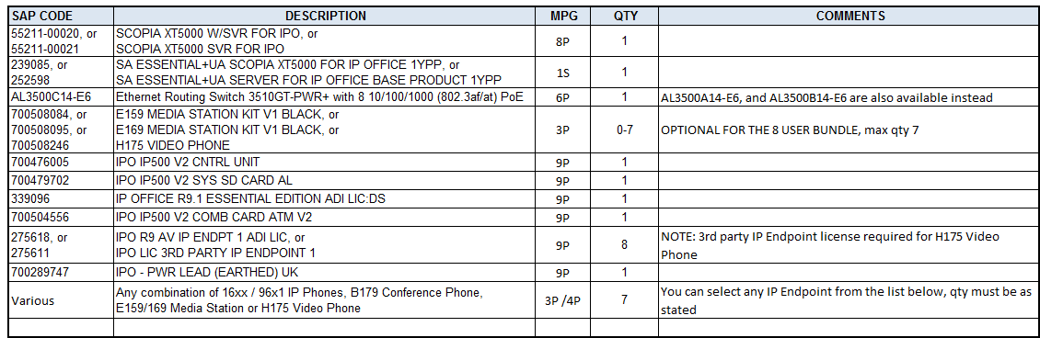

48 USER BUNDLE
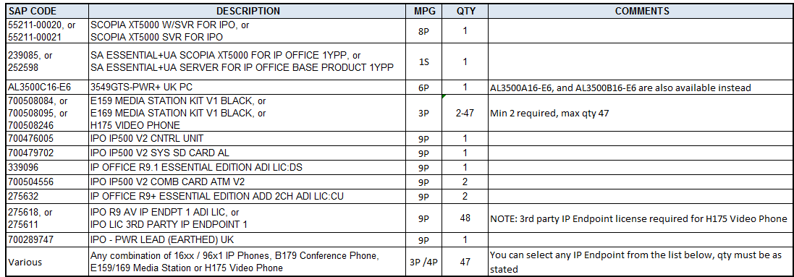

96 USER BUNDLE
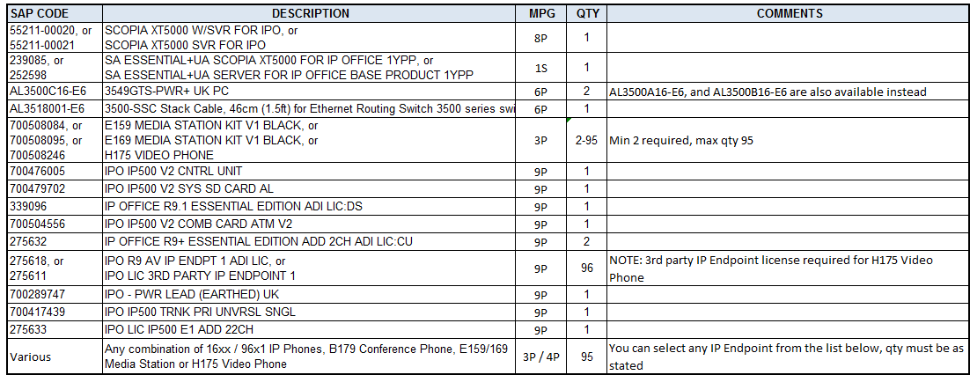

ELIGIBLE IP PHONES
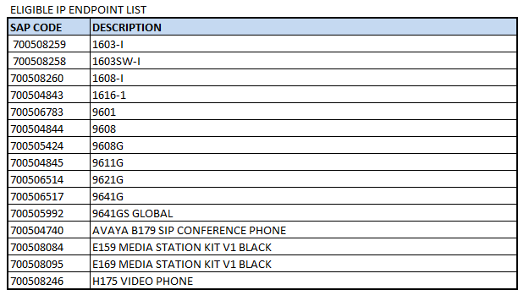

© 2015 Avaya Inc.
All Rights Reserved. Avaya and the Avaya Logo are trademarks of Avaya Inc. and may be registered in certain jurisdictions. All trademarks identified by ®, TM or SM are registered marks, trademarks, and service marks, respectively, of Avaya Inc All other trademarks are the property of their respective owners.

